**CyberTrack**

**System Requirements**

**Specification (SyRS)**

**For**

**Hostel Self-Service kiosk**

**Version 2.0**

**February 19, 2020**

**Prepared by:**

**CyberTrack**

# 

# TABLE OF CONTENT

***Section Title Page***

**TABLE OF CONTENT** **2**

**1. Introduction** **3**

1.1 System purpose 3

1.2 System scope 3

1.3 System overview 4

1.3.1 System context 4

1.4 Definition 5

**2. References** **6**

**3. System requirements** **7**

3.1 Functional requirements 7

3.1.1 Check-in 8

3.1.2 View Locker 8

3.1.3 Check out 8

3.1.4 Return key 8

3.1.5 Print receipt 9

3.1.6 Scan Student ID 9

3.1.7 Login as student 9

3.1.8 Check Room Type 9

3.1.9 View Map 10

3.1.10 View Room Location 10

3.1.11 Pay Hostel Fee 10

3.1.12 Select payment method 10

3.1.13 Pay through online 11

3.1.14 Pay through bank wave 11

3.1.15 Scan bank card 11

3.1.16 Select Service 11

3.1.17 Provide Feedback 12

3.1.18 Provide Complain 12

3.2 System modes and states 13

3.3 logical database requirements 16

3.4 Quality requirements 16

**4. Design Constraints** **18**

# 1. Introduction

## 1.1 System purpose

The purpose of the Hostel Self Services kiosk is to provide faster ways for the student to check in and check out during registration hostel instead of querying for a long time. So, It can reduce the waiting time during the registration days at the hostel.

## 1.2 System scope

Scope of the Hostel Self Service kiosk are:

* Check-in for the hostel’s room.
  + When the student uses the Hostel Self Service kiosk to check-in for the hostel room, the system shall display the selection of the room type and the insertion text which is used to key in the booking id.

After the student key in booking id, if the booking id is invalid, the system will display the booking id is invalid and loop the page of the insertion page, else if the booking id is valid, the system will display the details of the booking id and ask the student to confirm to check in this room.

After the student confirms for check-in, The system will display the locker to instruct the student to get the key from the locker.

* Check out from the hostel’s room.
  + If the student wishes to check-out from the room, the student must log in to the Hostel Self Service Kiosk to verify their status as residents. Then the student shall initiate the request by pressing the “Check-Out” button and then the system will display the details of the request and check-out status. Then the student then will confirm their request to check-out. Afterwards, the system will give the locker number to the resident so that they can return the room key. After returning the key, the resident can choose whether to print the receipt or not.
* View detailed of the hostel’s room.
  + The student will know all of the details of the hostel room when the student chooses the view detailed of the Hostel Self Service Kiosk.
* Allow the users to feedback for the system.
  + Students can send the feedback or complain about the hostel or the hostel self-services system to the staff by using the provided feedback or complaint in the Hostel Self Service Kiosk.
* Show the map of the hostel.
  + Student can view the map of the hostel when students select view map. The map will show the room location and the hostel’s features. Student can search for the location of the room by entering the room id in search.
* provide the payment method.
  + Student can choose bank card or online banking to pay the fee of the hostel’s room.

## 1.3 System overview

### 1.3.1 System context

The major elements that are involved in the Hostel Self-Services kiosk are the students who are studying in University, the scanner that is used to scan the Student ID card, the scanner that are used to scan for the Bankcard.

The flow of the system is as follows:

1. The user shall log in as a student to verify their status as a student. Then, the system prompts the student to enter the booking details. Afterwards, the system will display the booking details and personal details. The student needs to double-check all the details and then press the confirm check-in button and it will display the locker number which contains the key to their room.
2. The student can check the room type by clicking the button. It will prompt the student ID and verify the ID. after the students status is being verified, it will display the double and triple sharing room details.
3. The student also can make the payment through the kiosk. The student must log in as a student and after being verified. It will display the pending payment details and then proceed with the payment. After the payment is approved, the system will display the details of the payment and it will give the option to print the receipt.
4. The student also can view the map of the hostel by login as a student and a resident. The student that login as a student, it will have their status being verified and then display the map of the MMU hostel. While on the other hand, if the student login a resident, and after being verified, it will display the resident details also with the map of the hostel to their room location.
5. The student also can give feedback to the staff through the system. First, the student needs to log in as a student to verify their status as a student. After verified, only then the student can write feedback
6. The resident shall log in first to verify their status as a resident of the hostel. Then, the system will prompt the check-out button and after the button is pressed, the system then will display the details of the request and the check-out detail. The resident will then double-check all the details and confirm their request to check-out by pressing the “Confirm” button. Afterwards, the system will give the locker number to the resident so that they can return the room key. After returning the key, the resident can choose whether to print the receipt or not.

## 1.4 Definition

Student/Resident - user that wants to use the Hostel Self-Service Kiosk to apply to the MMU hostel accommodation

Staff - the staff of the MMU Hostel that is responsible to manage all hostel services.

Check-In - A process to confirm the student/resident to check-in their hostel room

Check-Out - A process to confirm the student/resident that requested to check-out from their hostel room

Map - a feature where its display the map of MMU hostel and the resident room location.

Room Type - user can use this feature to view the room type that is available in the hostel.

Service Desk - user can file a complaint to the staff through this feature as well as give constructive feedback.

Payment - user can make a payment via an online payment gateway.

# 2. References

The document that has been prepared in accordance with the following documents:

i. ISO/IEC/IEEE 29148:2011(E), Systems and software engineering - Life cycle processes - Requirements engineering.

# 

# 

# 

# 

# 

# 

# 

# 

# 

# 

# 3. System requirements

## 3.1 Functional requirements

#### 3.1.1 Check-in

|  |  |  |  |
| --- | --- | --- | --- |
| Requirement ID | R-001 | Version | 1.0 |
| Author | Low Sheng Rong | | |
| Description | The system shall provide students with the ability to check in the hostel's room. | | |

#### 3.1.2 View Locker

|  |  |  |  |
| --- | --- | --- | --- |
| Requirement ID | R-002 | Version | 1.0 |
| Author | Low Sheng Rong | | |
| Description | When students confirm to check-in for the hostel’s room, the system shall provide students with the ability to view the locker number where the locker contains the key of the hostel’s room. | | |

#### 3.1.3 Check out

|  |  |  |  |
| --- | --- | --- | --- |
| Requirement ID | R-003 | Version | 1.0 |
| Author | Low Sheng Rong | | |
| Description | The system shall provide students with the ability to check out the hostel's room. | | |

#### 3.1.4 Return key

|  |  |  |  |
| --- | --- | --- | --- |
| Requirement ID | R-004 | Version | 1.0 |
| Author | Low Sheng Rong | | |
| Description | When students confirm to check out the hostel’s room, the system shall provide students with the ability to return the key to the locker. | | |

#### 3.1.5 Print receipt

|  |  |  |  |
| --- | --- | --- | --- |
| Requirement ID | R-005 | Version | 1.0 |
| Author | Low Sheng Rong | | |
| Description | When students return key, the system might provide students with the ability to print the receipt. | | |

#### 3.1.6 Scan Student ID

|  |  |  |  |
| --- | --- | --- | --- |
| Requirement ID | R-006 | Version | 1.0 |
| Author | Low Sheng Rong | | |
| Description | The system shall be able to scan student ID card by using the scanner | | |

#### 3.1.7 Login as student

|  |  |  |  |
| --- | --- | --- | --- |
| Requirement ID | R-007 | Version | 1.0 |
| Author | Low Sheng Rong | | |
| Description | When the system gets the student ID, the system shall provide students with the ability to log in as a student. | | |

#### 3.1.8 Check Room Type

|  |  |  |  |
| --- | --- | --- | --- |
| Requirement ID | R-008 | Version | 1.0 |
| Author | Low Sheng Rong | | |
| Description | The system shall provide students with the ability to check the details of the hostel’s room. | | |

#### 3.1.9 View Map

|  |  |  |  |
| --- | --- | --- | --- |
| Requirement ID | R-009 | Version | 1.0 |
| Author | Low Sheng Rong | | |
| Description | The system shall provide students with the ability to view a map of the hotel's room. | | |

#### 3.1.10 View Room Location

|  |  |  |  |
| --- | --- | --- | --- |
| Requirement ID | R-010 | Version | 1.0 |
| Author | Low Sheng Rong | | |
| Description | When the student login as student and student have hostel room, The system shall provide students with the ability to view room located on the map. | | |

#### 3.1.11 Pay Hostel Fee

|  |  |  |  |
| --- | --- | --- | --- |
| Requirement ID | R-011 | Version | 1.0 |
| Author | Low Sheng Rong | | |
| Description | The system shall provide students with the ability to pay the hostel fee. | | |

#### 3.1.12 Select payment method

|  |  |  |  |
| --- | --- | --- | --- |
| Requirement ID | R-012 | Version | 1.0 |
| Author | Low Sheng Rong | | |
| Description | The system shall provide students with the ability to select the payment method for paying the fee. | | |

#### 3.1.13 Pay through online

|  |  |  |  |
| --- | --- | --- | --- |
| Requirement ID | R-013 | Version | 1.0 |
| Author | Low Sheng Rong | | |
| Description | The system shall provide students with the ability to pay the fee through online banking | | |

#### 3.1.14 Pay through bank wave

|  |  |  |  |
| --- | --- | --- | --- |
| Requirement ID | R-014 | Version | 1.0 |
| Author | Low Sheng Rong | | |
| Description | The system shall provide students with the ability to pay the fee through bank wave | | |

#### 3.1.15 Scan bank card

|  |  |  |  |
| --- | --- | --- | --- |
| Requirement ID | R-015 | Version | 1.0 |
| Author | Low Sheng Rong | | |
| Description | The system shall be able to scan the bank card to process bank wave by using the scanner. | | |

#### 3.1.16 Select Service

|  |  |  |  |
| --- | --- | --- | --- |
| Requirement ID | R-016 | Version | 1.0 |
| Author | Low Sheng Rong | | |
| Description | The system shall provide students with the ability to select the service. | | |

#### 3.1.17 Provide Feedback

|  |  |  |  |
| --- | --- | --- | --- |
| Requirement ID | R-017 | Version | 1.0 |
| Author | Low Sheng Rong | | |
| Description | The system shall provide students with the ability to provide feedback on the system to the staff | | |

#### 3.1.18 Provide Complain

|  |  |  |  |
| --- | --- | --- | --- |
| Requirement ID | R-018 | Version | 1.0 |
| Author | Low Sheng Rong | | |
| Description | The system shall provide students with the ability to give the complaint of the system to the staff. | | |

## 

## 3.2 System modes and states

[**https://drive.google.com/file/d/1SZPH0bi5Jkm-B-tCvkW_mWUbCixEqNQf/view?usp=sharing**](https://drive.google.com/file/d/1SZPH0bi5Jkm-B-tCvkW_mWUbCixEqNQf/view?usp=sharing)

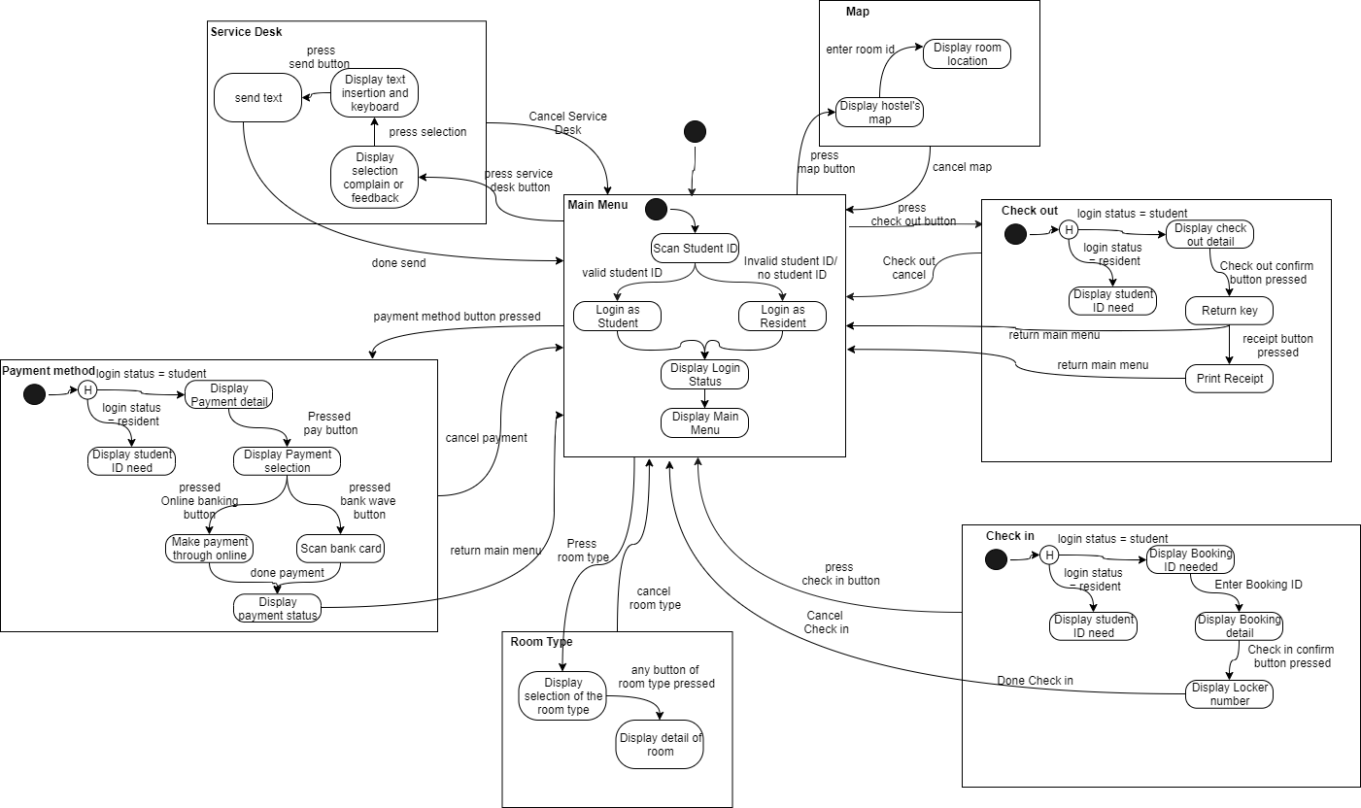

The diagram above shows the state diagram of the Hostel Self-Services Kiosk

|  |  |  |
| --- | --- | --- |
| **Mode** | **State** | **Description** |
| Main Menu | Display Main Menu | The main menu of the Hostel Self Services kiosk that shows multiple buttons of Check In button, Check Out button, View Room Type button, Map button, Service Desk button. |
| Scan Student ID | Scan student Id card to get the information of the student |
| Login as Student | The system change the login status to student |
| Login as Resident | The system change the login status to resident |
| Display Login Status | The system show the status of the login |
| Check-in | Display student id need | The system will inform to do this process student shall take student ID card to login. |
| Display booking id needed | Provide students the text fill to let the student to fill the booking id to it. |
| Display booking id detail | Provide the information of the booking id to the student. |
| Display locker number | Provide the number of the locker to the student to instruct the student to get the hostel’s roomkey. |
| Check-Out | Display student id need | The system will inform to do this process student shall take student ID card to login. |
| Display check out detail | Provide the information of the check out to the student. |
| Return key | Display the locker to instruct student to return key to the locker. |
| Print Receipt | Provide the student with the ability to print the receipt. |
| Room Type | Display selection of the room type | Display the selection of the room type to let the student select to view the detail. |
| Display detail of room | Display the room type and details to the student. |
| Map | Display hostel’s map | Display the layout of the hostel. |
| Display room location | Display the student room location. |
| Payment method | Display student id need | The system will inform to do this process student shall take student ID card to login. |
| Display payment detail | Display the overall of the student’s hostel fee. |
| Display Payment method | Display options for payment gateway; which is the paywave and online banking |
| Make payment through online | Provide student to make payment through online |
| Scan bank card | Provide a scanner to scan the student’s bank card to pay the fee. |
| Display payment status | Display the payment status which iis success or failed to the student. |
| Service desk | Display selection complaint or feedback | Allow the student/resident to file a complaint or give feedback |
| Display text insertion and keyboard | Display the text filled to allow the student to write the feedback or complaint. |
| Send text | Provide student with the ability to send the complaint or feedback to the staff of the hostel. |

## 

## 

## 

## 

## 

## 3.3 logical database requirements

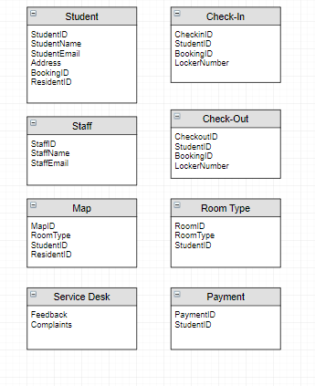

## 3.4 Quality requirements



## 

|  |  |  |  |
| --- | --- | --- | --- |
| Requirement ID | R-020 | Version | 1.0 |
| Author | Low Sheng Rong | | |
| Description | Log in as a student shall be done by using student ID card shall take 2 seconds at most. | | |
| Type of Quality | Performance efficiency | | |

## 

|  |  |  |  |
| --- | --- | --- | --- |
| Requirement ID | R-021 | Version | 1.0 |
| Author | Low Sheng Rong | | |
| Description | Search for the location of the room shall take 1.5 seconds at most. | | |
| Type of Quality | Performance efficiency | | |

## 

|  |  |  |  |
| --- | --- | --- | --- |
| Requirement ID | R-022 | Version | 1.0 |
| Author | Low Sheng Rong | | |
| Description | The process of the check in for the room shall take within 5 seconds. | | |
| Type of Quality | Performance efficiency | | |

## 

|  |  |  |  |
| --- | --- | --- | --- |
| Requirement ID | R-023 | Version | 1.0 |
| Author | Low Sheng Rong | | |
| Description | The process of the check out for the room shall take within 5 seconds. | | |
| Type of Quality | Performance efficiency | | |

## 



## 

|  |  |  |  |
| --- | --- | --- | --- |
| Requirement ID | R-025 | Version | 1.0 |
| Author | Low Sheng Rong | | |
| Description | Payment process shall take 5 seconds at most. | | |
| Type of Quality | Performance efficiency | | |

## 

|  |  |  |  |
| --- | --- | --- | --- |
| Requirement ID | R-026 | Version | 1.0 |
| Author | Low Sheng Rong | | |
| Description | When the student takes away the student id card from the scanner, the system shall login as a resident within 1 seconds. | | |
| Type of Quality | Performance efficiency | | |

# 

# 4. Design Constraints

* Platform:
  + Must work on the kiosk
* Operating System:
  + Must have at least Windows 98 or above
* Hardware:
  + At least 128 MB of RAM
  + Minimum 1920 x 1080 screen resolution with 256 colors
  + Response time is 6ms
  + Touch screen is optional TouchFoil or PROS or infrared
  + Wireless network card/3G supports for remote control
  + Power supply: 65 to 265V, 50/60Hz AC, power less than 100W
* Software:
  + Ability to process magnetic stripe data
  + Local logs transferred to CSM for error monitoring
  + Online reporting suite in real-time
  + Font formatting for printed receipts
* Legal:
  + The system shall comply to the law such as:
    - Financial Service Act 2013 (FSA) – Section 33 – Power of Bank to specify standards for payment system
    - Credit Card Accountability Responsibility and Disclosure Act 2009 (Credit CARD Act) – Section 119 – Secrecy

**Division of Work**

Table 1.1 below shows the division of tasks that have been delegated by all the members in this group for this project development on preparing the documentation and the background study.

|  |  |  |  |
| --- | --- | --- | --- |
| **TASKS** | **STUDENTS** | | |
|  | Shen Rong | Azif | Syahmi |
| System Purpose | **X** |  |  |
| System Scope | **X** | X | X |
| System Context |  | X | X |
| Definition |  | X | X |
| References |  |  | X |
| Functional Requirements | X |  |  |
| System Modes and States | X | X | X |
| Logical Database Requirements |  |  | X |
| Quality Requirements | X |  |  |
| Design Constraint | X | X |  |
| Meeting Minutes |  | X |  |
|  |  |  |  |
|  |  |  |  |
|  |  |  |  |
|  |  |  |  |
|  |  |  |  |
|  |  |  |  |
|  |  |  |  |
|  |  |  |  |

**Appendix A: Meeting minutes**

Meeting 1:

|  |
| --- |
| 1. **Purpose of Meeting** |
| First Meet of SyRS team meeting |

|  |  |  |
| --- | --- | --- |
| 1. Date of Meeting | 1. Attendees | 1. Location |
| 14th of January (2 P.M.) | Azif  Shen Rong  Syahmi | FACULTY OF COMPUTING |

|  |  |  |
| --- | --- | --- |
| 1. Meeting Agendas |  |  |
| 1. Delegate task 2. Discuss about possible content in SyRS 3. Review current system | | |

***Meeting 2:***

|  |
| --- |
| 1. **Purpose of Meeting** |
| Second Meeting of SyRS team |

|  |  |  |
| --- | --- | --- |
| 1. Date of Meeting | 1. Attendees | 1. Location |
| 17 January (2 P.M.) | Azif  Shen Rong  Syahmi | FACULTY OF ENGINEERING  (TUTORIAL ROOM) |

|  |  |  |
| --- | --- | --- |
| 1. Meeting Agendas |  |  |
| 1. Discuss about the scenario and use case 2. Analyse other current existing system 3. Refer to Standard Operating Procedure | | |

Meeting 3:

|  |
| --- |
| 1. **Purpose of Meeting** |
| Third Meeting of SyRS team |

|  |  |  |
| --- | --- | --- |
| 1. Date of Meeting | 1. Attendees | 1. Location |
| 21 January (2 P.M.) | Azif  Shen Rong  Syahmi | FACULTY OF COMPUTING |

|  |  |  |
| --- | --- | --- |
| 1. Meeting Agendas |  |  |
| 1. Gather information that we obtained previously 2. Discussed for the possible content that we could add up 3. Finishing project | | |